Islamic Extremism: Common Concern for Muslim and Western Publics
Support for Terror Wanes Among Muslim Publics
Released: 07.14.05
Navigate this report
Summary of Findings
About the Pew Global Attitudes Project
I. How Muslims and Westerners See Each Other
II. How Non-Muslim Publics View Muslims
III. How Muslims See Themselves and Islam's Role
IV. How Muslims View Relations with the World
Methodological Appendix
Questionnaire
Summary of Findings
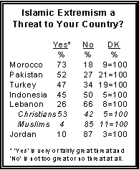
Concerns over Islamic extremism, extensive in the West even before this month's terrorist attacks in London, are shared to a considerable degree by the publics in several predominantly Muslim nations surveyed. Nearly three-quarters of Moroccans and roughly half of those in Pakistan, Turkey and Indonesia see Islamic extremism as a threat to their countries. At the same time, most Muslim publics are expressing less support for terrorism than in the past. Confidence in Osama bin Laden has declined markedly in some countries and fewer believe suicide bombings that target civilians are justified in the defense of Islam.
Nonetheless, the polling also finds that while Muslim and non-Muslim publics share some common concerns, they have very different attitudes regarding the impact of Islam on their countries. Muslim publics worry about Islamic extremism, but the balance of opinion in predominantly Muslim countries is that Islam is playing a greater role in politics – and most welcome that development. Turkey is a clear exception; the public there is divided about whether a greater role for Islam in the political life of that country is desirable.
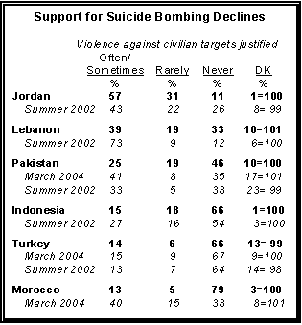
In non-Muslim countries, fears of Islamic extremism are closely associated with worries about Muslim minorities. Western publics believe that Muslims in their countries want to remain distinct from society, rather than adopt their nation's customs and way of life. Moreover, there is a widespread perception in countries with significant Muslim minorities, including the U.S., that resident Muslims have a strong and growing sense of Islamic identity. For the most part, this development is viewed negatively, particularly in Western Europe. In France, Germany and the Netherlands, those who see a growing sense of Islamic identity among resident Muslims overwhelmingly say this is a bad thing.
The latest survey by the Pew Global Attitudes Project, conducted among more than 17,000 people in 17 countries this spring, finds that while many Muslims believe that radical Islam poses a threat, there are differing opinions as to its causes. Sizable minorities in most predominantly Muslim countries point to poverty, joblessness and a lack of education, but pluralities in Jordan and Lebanon cite U.S. policies as the most important cause of Islamic extremism.
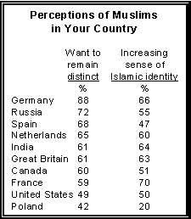
The polling also finds that in most majority-Muslim countries surveyed, support for suicide bombings and other acts of violence in defense of Islam has declined significantly. In Turkey, Morocco and Indonesia, 15% or fewer now say such actions are justifiable. In Pakistan, only one-in-four now take that view (25%), a sharp drop from 41% in March 2004. In Lebanon, 39% now regard acts of terrorism as often or sometimes justified, again a sharp drop from the 73% who shared that view in 2002. A notable exception to this trend is Jordan, where a majority (57%) now says suicide bombings and other violent actions are justifiable in defense of Islam.
When it comes to suicide bombings in Iraq, however, Muslims in the surveyed countries are divided. Nearly half of Muslims in Lebanon and Jordan, and 56% in Morocco, say suicide bombings against Americans and other Westerners in Iraq are justifiable. However, substantial majorities in Turkey, Pakistan and Indonesia take the opposite view.
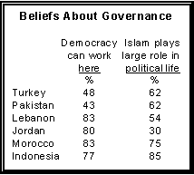
As in past Global Attitudes surveys, publics in predominantly Muslim countries believe that democracy can work in their countries. Large and growing majorities in Morocco (83%), Lebanon (83%), Jordan (80%) and Indonesia (77%) – as well as pluralities in Turkey (48%) and Pakistan (43%) – say democracy can work well and is not just for the West.
Yet there is some ambivalence about the role of Islam in government. Majorities or pluralities in each of the predominantly Muslim countries surveyed, except for Jordan, say Islam is playing a greater role in politics than a few years ago. But those who see Islam playing a large role in political life are also somewhat more likely to say that Islamic extremism poses a threat to their countries.
Overall, the sense that Islamic extremism poses a major national threat is strongest in Morocco, the site of a devastating terrorist attack two years ago, where nearly three-quarters of the public (73%) hold that view. In Pakistan, 52% believe Islamic extremism presents a very or fairly great threat to the country, as do 47% in Turkey. In Lebanon, opinions are divided, with Christians much more likely to see Islamic extremism as a threat than Muslims. And just 10% of Jordanians view Islamic extremism as at least a fairly great threat.
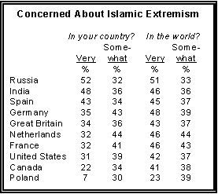
Outside the Muslim world, the Pew survey finds that in countries such as India, Russia, Germany and the Netherlands, concerns about Islamic extremism – both within their own borders and around the world – are running high. Worries over Islamic extremism are nearly as high in France and Spain. Concerns about terrorism at home and around the world run parallel in only three countries, Russia, India and Spain. Before the London terrorist attacks, Americans and Britons expressed more concern about extremism around the world than they did at home.
There also is evidence that these concerns are associated with opposition to Turkey's entry into the European Union. Overall, nearly two-thirds of French (66%) and Germans (65%) oppose Turkey's EU bid, as do a majority of the Dutch (53%). Support for Turkey's admittance to the EU is most extensive in Spain (68%) and Great Britain (57%).
An analysis of the polling finds that opposition to Turkey's admission is also tied to growing concerns about national identity. Negative views about immigration – not only from the Middle East and Africa but from Eastern Europe as well – are even more strongly related to opposition to Turkey's admission to the EU than are concerns over Islamic extremism.
Nonetheless, favorable views of Muslims outpace negative views in most countries of North America and Europe. Hostility toward Muslims is much lower in Great Britain, the United States and Canada than in other Western countries surveyed. And while worries about Islamic extremism are substantial in these three English speaking countries, the survey found somewhat less concern about rising Islamic identity among their resident Muslim populations.

Islam in Politics
A complex set of attitudes about the place of Islam in politics emerges from the findings. Most people surveyed in predominantly Muslim countries identify themselves first as Muslims, rather than as citizens of their country. Moreover, except in Jordan, there is considerable acknowledgement that Islam is playing a significant role in the political life of these countries.
Worries about extremism are often greater among those who believe Islam has a significant voice in the political life of their country. This is particularly the case in Turkey and Morocco. The polling finds that those in Turkey who self-identify primarily with their nationality worry more about Islamic extremism than do those who think of themselves first as Muslim.
However, Muslim publics who see Islam's influence in politics increasing say that this trend is good for their country, while those who see Islam's influence slipping overwhelmingly say it is bad. Turkey, whose EU candidacy is weakened by European worries about Islamic extremism, has the least clear cut opinions on this issue. An increasing role for Islam in politics in Turkey, a country that has been officially secular since 1923, is seen as a bad thing. Those in Turkey who see Islam's influence diminishing are divided over whether this is good (44%) or bad (47%).

Views of Religious Groups
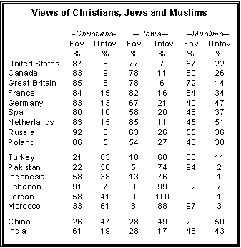
Majorities in Great Britain, France, Canada, the U.S. and Russia, as well as pluralities in Spain and Poland, say they have a somewhat or very favorable view of Muslims. In the West, only among the Dutch and Germans does a majority or plurality hold unfavorable views of Muslims (51% and 47%, respectively).
For their part, people in predominantly Muslim countries have mixed views of Christians and strongly negative views of Jews. In Lebanon, which has a large Christian minority, 91% of the public thinks favorably of Christians. Smaller majorities in Jordan and Indonesia also have positive views of Christians. However, in Turkey (63%), Morocco (61%) and Pakistan (58%), solid majorities express negative opinions of Christians.
Anti-Jewish sentiment is endemic in the Muslim world. In Lebanon, all Muslims and 99% of Christians say they have a very unfavorable view of Jews. Similarly, 99% of Jordanians have a very unfavorable view of Jews. Large majorities of Moroccans, Indonesians, Pakistanis and six-in-ten Turks also view Jews unfavorably.
In the Asian countries surveyed, views of religious groups are generally more moderate. India, with its substantial Muslim minority, is closely divided with respect to views about Muslims; 46% hold a favorable view while 43% view them unfavorably. Opinions of Christians are considerably higher: 61% favorable compared with 19% unfavorable. Most Indians (56%) offer no opinion on Jews; those that do split 28% favorable to 17% unfavorable.
In China, half view Muslims unfavorably while only 20% hold a favorable opinion. Views about Christians are scarcely better: 47% unfavorable compared with 26% favorable. Chinese views of Jews are essentially the same as their attitudes toward Christians: 49% negative vs. 28% positive.
In most of Europe as well as North America, majorities or pluralities judge some religions as more prone to violence than others, and those that do mostly have Islam in mind. Similarly, in India, among the 39% who see some religions as more violent than others, nearly three-in-four (73%) point to Islam, while 17% designate Hinduism. In predominantly Muslim countries, many agree that some religions are more prone to violence than others, but those who think this mostly have Judaism in mind. In Turkey, a plurality sees Christianity as the most violent.

Ban Muslim Head Scarves?
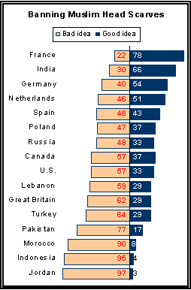
On another controversial issue, the prohibition on wearing head scarves by Muslim women in public places including schools, attitudes are uniformly negative in the Muslim world but differ sharply among non-Muslim countries.
Majorities in the U.S., Canada and Great Britain, as well as pluralities in Spain, Russia and Poland, view such prohibitions as a bad idea. However, in France, where a ban on wearing head scarves and other "conspicuous" religious symbols in secular schools went into effect last year, a large majority (78%) favors such prohibitions. They are joined in this view by smaller majorities in Germany (54%), the Netherlands (51%) and by nearly two-thirds of the Indian public (66%).
In Turkey, where a longstanding ban on head scarves in schools and public buildings has come under increasing attack from Muslim activists, 64% of the public calls such a ban a bad idea compared with 29% who view it as a good idea. Lebanon weighs in against head scarf bans by 59% opposed to 29% in favor, while even larger majorities in Jordan (97%), Indonesia (95%), Morocco (90%) and Pakistan (77%) call them a bad idea.

Views of bin Laden
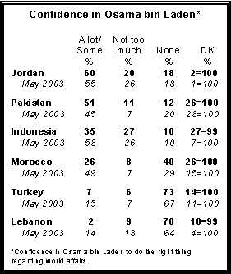
While support for suicide bombings and other terrorist acts has fallen in most Muslim-majority nations surveyed, so too has confidence in Al Qaeda leader Osama bin Laden. In Lebanon, just 2% report some or a lot of confidence in bin Laden, and in Turkey only 7% do so.
In Morocco, just 26% of the public now say they have a lot or some confidence in bin Laden, down sharply from 49% in May 2003. In Indonesia, the public is now about evenly split, with 35% saying they place at least some confidence in bin Laden and 37% saying they have little or none; that represents a major shift since 2003, when 58% expressed confidence in bin Laden.
In Pakistan, however, a narrow majority (51%) places some measure of confidence in bin Laden, a slight increase from 45% in 2003. And in Jordan, support for the Al Qaeda leader has risen over the last two years from 55% to a current 60%, including 25% who say they have a lot of confidence in him. Unsurprisingly, support for bin Laden in non-Muslim countries is measured in the small single digits.
Declining support for terror in a number of the Muslim countries surveyed tracks with previously reported dramatic increases in favorable views of the United States in Indonesia and Morocco. Favorable opinions of the U.S. surged most among younger people in Morocco, but were equally evident among both the young and old in Indonesia. The polling also found that in most Muslim countries women were less likely to express an opinion of the U.S. than were men, but when they did, they held a somewhat more positive view.

Roadmap to the Report
The first section of the report analyzes how people in Western countries view people of the Muslim faith and how people in predominantly Muslim countries view people of the Christian and Jewish faiths. It also looks at attitudes toward the banning of Muslim head scarves in some countries and differing views of the U.S. among demographic groups in Muslim countries. Section II focuses on concerns in non-Muslim countries about growing Islamic identity and extremism as well as opinions about Turkey's bid to join the European Union. Section III deals with Muslims' perceptions of themselves and the role of Islam in the political life of their home country, and concerns about Islamic extremism within their own borders. A final section explores views in predominantly Muslim countries of Islam's role in the larger world and support for acts of terrorism in support of Islam both generally and specifically against the U.S. and its allies in Iraq. At the end of each section, excerpts from interviews conducted by the International Herald Tribune are included to illustrate some of the themes covered by the survey.
A description of the Pew Global Attitudes Project and a list of the countries surveyed immediately follows. A summary of the methodology can be found at the end of the report, along with complete results for all countries surveyed.

